SQL CLASS -

TOPICS – Order by Clause

Order By Clause –

- Order by clause is used to sort the records in your result set. The Order By clause can only be used in Select statements.
- If the ASC or DESC modifier is not provided in the Order by clause, the results will be sorted by expression in ascending order. This is equivalent to Order By expression ASC.
- You can also use the Order by clause to sort by relative position in the result set, where the first field in the result set is 1. The next field is 2, and so on.
- When sorting your result set using the Order by clause, you can use the ASC and DESC attributes in a single select statement.
- SQL treats NULL as the lowest values.
- The Order by clause is the very last clause to be processed in Select Statement.
- It is possible to sort the result set by a column that does not appear on the select list.
- NULLS FIRST places NULL values before non-NULL values and NULLS LAST puts the NULL values after Non-NULL values.

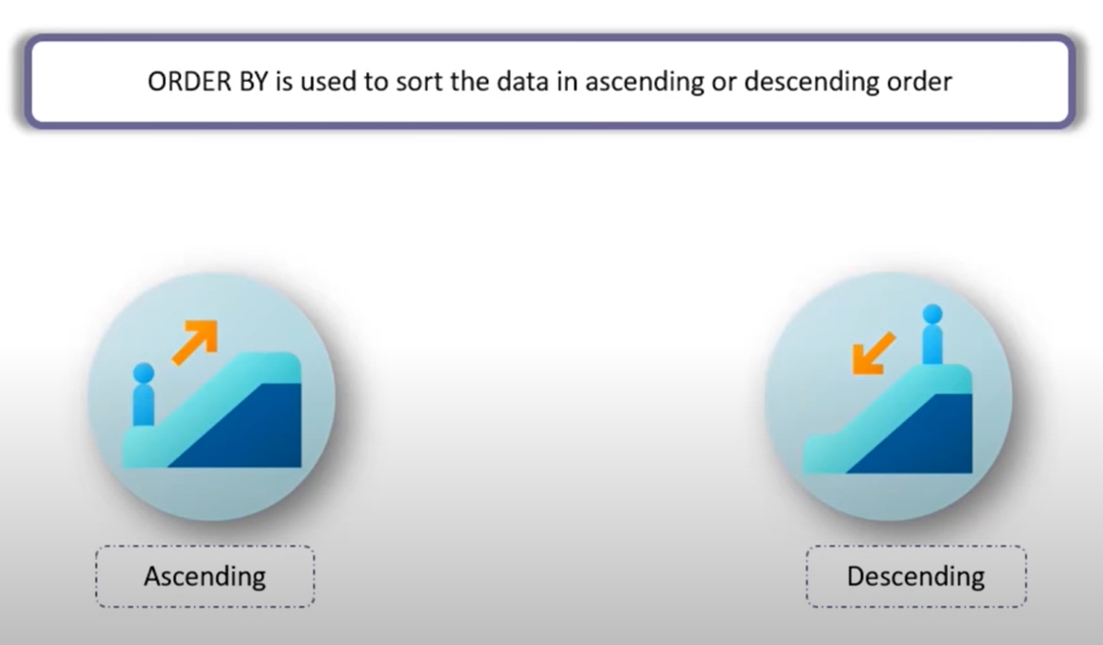

Syntax -
SELECT column_list FROM table_name
[WHERE search_condition] ;
ORDER BY column_list [ ASC | DESC ];

Example -

CREATE TABLE vendors
(
vendor_id NUMBER,
vendor_name VARCHAR2(100),
vendor_country VARCHAR2(100),
vendor_price NUMBER
);

INSERT INTO vendors VALUES (1,'ABC Corp','India', 10000);
INSERT INTO vendors VALUES (2,'M-net','Bangladesh', 15000);
INSERT INTO vendors VALUES (3,'ABC Corp','South Africa', 10000);
INSERT INTO vendors VALUES (4, null,'Russia', 21000);
INSERT INTO vendors VALUES (5,'Synergy','USA', 29000);
INSERT INTO vendors VALUES (6,'M-net', null, 31000);
INSERT INTO vendors VALUES (7,'Synergy','Egypt', 45000);
INSERT INTO vendors VALUES (8,'Synergy','USA', 10000);
INSERT INTO vendors VALUES (9,'M-net', null, 5000);
INSERT INTO vendors VALUES (10,'Synergy','Angola', 54000);
INSERT INTO vendors VALUES (11, null,'India', 65000);
INSERT INTO vendors VALUES (11, null,'USA', 48000);

SELECT vendor_name FROM vendors;

Sorting records without using Asc and Desc keywords -
SELECT vendor_name FROM vendors ORDER BY vendor_name;
SELECT vendor_name, vendor_country FROM vendors ORDER BY vendor_name;

Sorting records using Asc and Desc keywords -
SELECT vendor_name FROM vendors ORDER BY vendor_name Asc;
SELECT vendor_name FROM vendors ORDER BY vendor_name Desc;

SELECT vendor_name, vendor_country FROM vendors ORDER BY vendor_name Asc;
SELECT vendor_name, vendor_country FROM vendors ORDER BY vendor_name Desc;

Sorting records using Asc and Desc keywords on multiple columns and different orders-

SELECT vendor_name, vendor_country FROM vendors ORDER BY vendor_name Asc, vendor_country Desc;
SELECT vendor_name, vendor_country FROM vendors ORDER BY vendor_name Desc, vendor_country Asc;

Sorting records using columns that is not in the select list -
SELECT vendor_name, vendor_price FROM vendors ORDER BY vendor_country Asc;
SELECT vendor_name, vendor_price FROM vendors ORDER BY vendor_country Desc;

Sorting records using expression -
SELECT vendor_name, vendor_country FROM vendors ORDER BY LENGTH(vendor_country) Asc;
SELECT vendor_name, vendor_country FROM vendors ORDER BY LENGTH (vendor_country) Desc;

Finding records using ordinal positions of columns -
SELECT vendor_name, vendor_country FROM vendors ORDER BY 1, 2;
SELECT vendor_name, vendor_country FROM vendors ORDER BY 1, 2 Desc;
SELECT vendor_name, vendor_country FROM vendors ORDER BY 1 Desc, 2 Asc;
SELECT vendor_name, vendor_country FROM vendors ORDER BY 3 Desc;
SELECT vendor_name, vendor_country, vendor_price FROM vendors ORDER BY 3 Desc;

Sorting rows with NULL values -
SELECT vendor_id, vendor_name FROM vendors ORDER BY vendor_name;
SELECT vendor_id, vendor_name FROM vendors ORDER BY vendor_name DESC;
SELECT vendor_id, vendor_name FROM vendors ORDER BY vendor_name ASC NULLS FIRST;
SELECT vendor_id, vendor_name FROM vendors ORDER BY vendor_name ASC NULLS LAST;
SELECT vendor_id, vendor_name FROM vendors ORDER BY vendor_name DESC NULLS FIRST;
SELECT vendor_id, vendor_name FROM vendors ORDER BY vendor_name DESC NULLS LAST;

__________________________THANK YOU____________________________

